**TAP KICK-OFF MINUTES**

**Thematic Annual Programming Kick-Off**

**Hosted by ANR**

**20th-21st of February 2025**

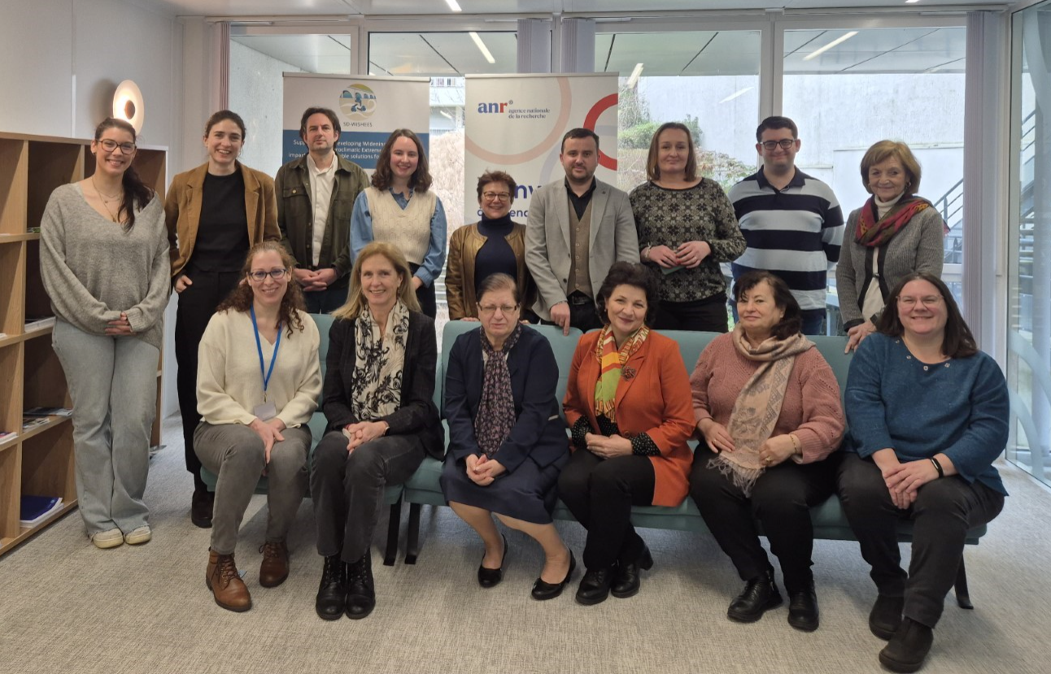

© Edith Santa Cruz (ANR)

**Authors of the report (in alphabetical order):**

Dr Esther Díez Cebollero, Scientific officer at ANR, SD-WISHEES WP3 leader

Ms Matilde Monnier, International project officer, ANR

Ms Julia Gavarrino, International Project officer, ANR

**TABLE OF CONTENT**

**1.** **Introduction** 3

**The SD-WISHEES project** 3

**The SD-WISHEES TAP** 3

**2.** **Introduction to the TAP** 5

**Objectives** 5

**Governance** 5

**3.** **Learning more about the TAP: the example of Water JPI** 6

**4.** **Getting to know each other: presentation of national projects** 7

**Museion** 7

**Scan4Art** 7

**Alteraqua** 7

**Chadwick Trail & Cohesion Fund** 7

**Extension of the Irrigation System by Constructing the Main Pipeline and 4 Lateral Branch Networks, Including the Installation of Hydrants, in the Outskirts of Telița Village, Anenii Noi District** 8

**Life-IP AdaptinGR** 8

**DIBIM** 9

**AGAPE** 9

**PENATE** 9

**5.** **Overview of the ARCHE/ Cultural Heritage Partnership** 10

**6.** **Widening challenges** 11

**7.** **First steps towards the Implementation Plan** 15

**8.** **Next steps** 16

**ANNEX I. List of attendees** 18

**ANNEX II. Agenda of the TAP kick-off meeting** 19

# **Introduction**

## **The SD-WISHEES project**

The acronym SD-WISHEES stands for “**S**upporting and **D**eveloping **WI**dening **S**trategies to tackle **H**ydroclimatic **E**xtreme **E**vents: impacts and **S**ustainable solutions for cultural heritage”. Officially launched in January 2023, SD-WISHEES aims to develop innovative tools and strategies to enable collaboration between diverse stakeholders in Europe and beyond to inclusively address the increasing threats posed to cultural heritage by hydroclimatic extreme events, such as droughts and floods. Cultural heritage encompasses not only historical and natural sites but also intangible assets like knowledge and traditions. Additionally, SD-WISHEES also contributes to EU and international policy frameworks related to the Sustainable Development Goals (SDGs) and widening strategies, ensuring that cultural heritage preservation remains a priority in the face of climate change challenges.

## **The SD-WISHEES TAP**

The SD-WISHEES TAP Action on the **“protection of cultural heritage in response to hydroclimatic extreme events**” currently brings projects from France, Greece, Malta, Moldova and Romania. However, additional projects/ countries may join the TAP up to six months after the Kick-off meeting.

This launch event introduced the TAP governance structure and objectives to the selected projects while also providing clarifications on the associated processes. More specifically, the launching event had four objectives:

**Objective 1: Presentation of TAP Governance and Objectives.**

**Objective 2: Introduction to participating projects and Discussions on activities to be developed by the group i.e. “Implementation Plan”.**

**Objective 3: Appointment of a Scientific Coordinator.**

**Objective 4: Identification of barriers for enlarging the participation of widening countries in the Framework Programme.**

ANR opened the TAP Kick-off and welcomed the participants with a few words from Inès Alterio (Deputy head of Department, International operations) who previously worked in SD-WISHEES WP3. The SD-WISHEES TAP is a strong opportunity to build a research network and foster collaboration between projects on climate change and cultural heritage.

To break the ice, a Mentimeter was set to get to know each participant and test the knowledge about cultural heritage & climate change. This anonymous survey was also the opportunity the learn more about the participants and their expectations of the TAP Kick-off.

***Q. What are you looking forward for this TAP Kick-Off?***

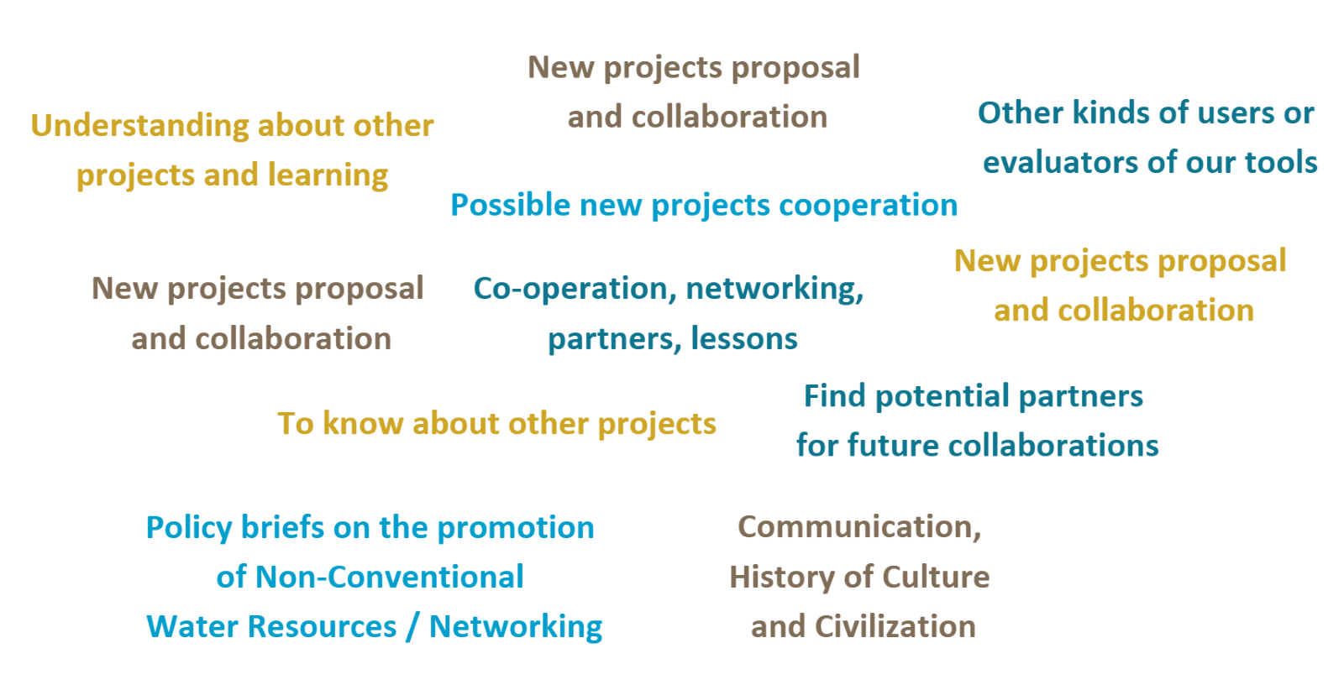

***Q. What is your area of expertise?***

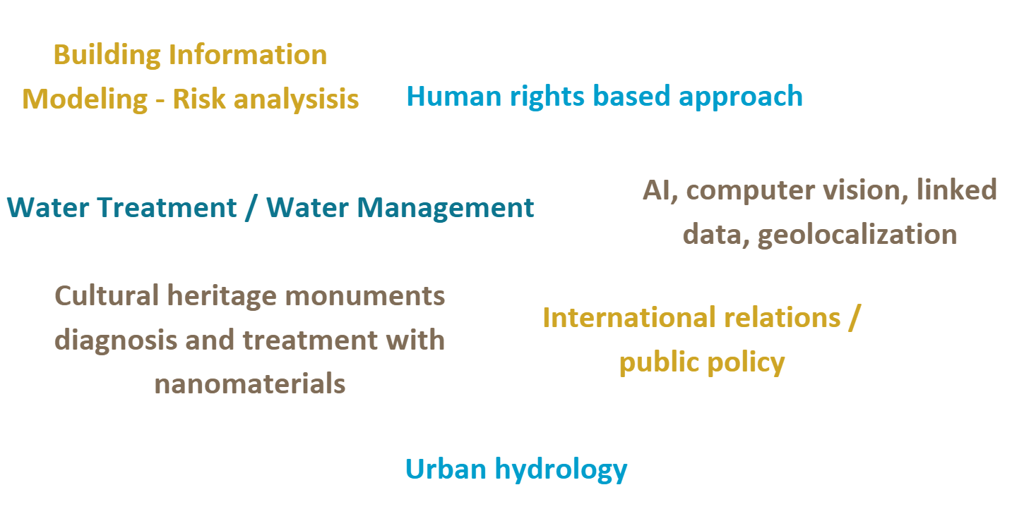

# **Introduction to the TAP**

Esther Diez Cebollero – SD-WISHEES project WP3 lead – ANR

## **Objectives**

The TAP is a **networking** and **collaborating** instrument between research nationally-funded projects on a common topic. The objectives of this instrument are to:

* **Enhance** the overall impact of cross-sector collaboration to address the protection and sustainable management of cultural heritage in Europe. The aim is also to have a better understanding of the impacts on cultural heritage, identify the best available adaptation solutions in response to hydroclimatic extreme events.
* **Enable** the exchange of knowledge, data, and research methodologies, giving research teams the possibility to expand their expertise in the domain and identify possible areas for cooperation.
* **Harmonize** national funding programs. Prior to launching the TAP, participating countries had to reach a consensus on the research themes of interest for the SD-WISHEES TAP. This represented an important effort that resulted in a Terms of References (ToR) document that thoroughly describes the themes of the TAP. This alignment effort also ensures that resources are effectively mobilized and that collaborative efforts are directed towards shared priorities.

## **Governance**

The TAP Action is formed by two bodies, the Steering Committee and the Action members. ANR is Chair of the TAP Action. Its role is to manage the TAP activities, oversee the deliverables, provide logistical and administrative support, and ensure the alignment with the SD-WISHEES project. Ms Julia Gavarrino is the ANR contact point. ANR’s role is also to support the Scientific coordinator, who ensures the scientific excellence of the TAP activities, leads the Implementation Plan outputs, and represents the TAP members in discussions with the Steering Committee.

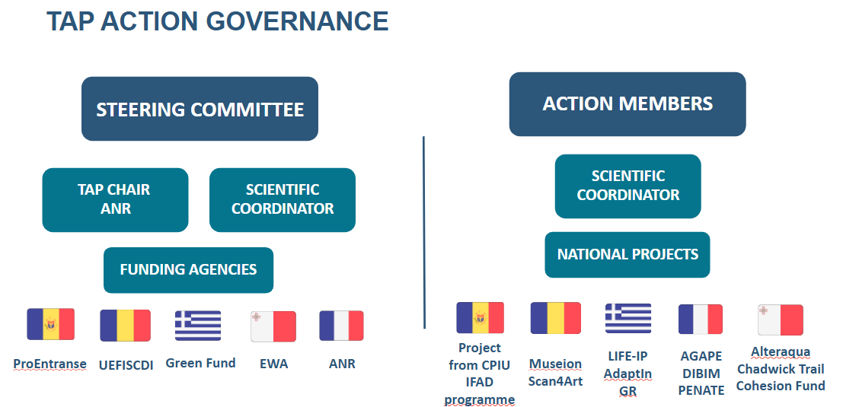

# **Learning more about the TAP: the example of Water JPI**

Mary Kelly Quinn - School of Biology & Environmental Science, University College Dublin

Dr Mary Kelly Quinn was the first-year scientific coordinator of the [**WATER JPI TAP on Ecosystem services (AQUATAP).**](http://www.waterjpi.eu/implementation/thematic-activities/water-jpi-tap-action/aquatap-es)This successful AQUATAP is a great example for the SD-WISHEES TAP in terms of outcomes and proceedings. Dr Quinn shared her experience as scientific co-coordinator, presented the outputs of the AQUATAP and the challenges encountered by the team. Based upon her experience, she also provided a number of recommendations for the successful implementation of the SD-WISHEES TAP.

**Recommendations and best practices to SD-WISHEES TAP members**

1. Define realistic objectives, not too ambitious
2. Share the workload between members – including the sharing of scientific coordination activities. In the case of the Water JPI’s TAP on ecosystem services, two different scientific coordinators were appointed – one year each. The overall workload for scientific coordinators was of around 0.5 days per week.
3. Build an interdisciplinary approach based each member’s expertise

--> Producing a booklet of each project and project coordinator defining their area of expertise was suggested.

1. Meet regularly; once every two to three months is necessary to evaluate progress in activities.
2. Take sufficient time (nearly three months) for the preparation of the Implementation Plan. It is a key document that will outline planned activities within the group.
3. It is essential to ensure the participation of stakeholders, as they will take up the results of activities.
4. Develop a glossary with key concepts so that all members (and stakeholders) have a common understanding of main concepts.

# **Getting to know each other: presentation of national projects**

Representatives of all TAP projects

The core of the TAP Kick-Off was the presentation of each national project participating in the TAP Action. 10 research projects from 5 different countries highlighted their research topics and expectations of the SD-WISHEES TAP on Cultural Heritage and Climate Change.

## **Museion**

Cristina Dobre – BEIA

George Sciu - BEIA

*The preservation of cultural heritage is challenged by environmental degradation caused by climate change. Existing climate control measures are often inefficient, costly, or not tailored to the specific needs of different heritage materials. The project tackles these issues by implementing an IoT-based system that integrates real-time monitoring, data analysis, and mitigation strategies for optimal environmental condition*

## **Scan4Art**

Rodica Ion – ICECHIM

*This project led to the development of 3D technologies for storing information in digital format and the integral 3D reconstruction of the medieval heritage of Dobrogea built of stone (Sacidava Fortress), a monument that has not been investigated so far.*

## **Alteraqua**

Nikos Skondras – GWP Med

*The Alter Aqua Project was born out of the urgent need to address Malta’s severe water scarcity while preserving its rich water-related cultural heritage. Malta is one of the most water-stressed countries in the world, with limited naturally occurring freshwater resources. The increasing demand for water, especially from the agricultural and tourism sectors, exacerbates the situation. One of the core aspects of the Alter Aqua Project is the preservation and revitalization of Malta’s historical underground rainwater harvesting reservoirs. These structures, dating back to ancient times, played a crucial role in securing water for communities. Over the years, however, many of these reservoirs fell into disrepair and were neglected. By restoring and reintegrating these reservoirs into modern water management systems, the project not only ensures water security but also safeguards a critical element of Malta’s cultural identity.*

## **Chadwick Trail & Cohesion Fund**

Alexander Borg representing project coordinators – EWA

***Chadwick Trail*** *project has for objectives to restore the site and develop the trail. To do so, the restoration work consists of:*

*(1) Water course, embankment and rubble wall restoration works: Branch-packing and removal of excess material from water storage areas.*

*(2) Placing markers on protected plants and trees during the clearing of invasive and overgrown vegetation.*

*(3) Restoring pathways to improve access to the Valley for visitors along with information points.*

***Cohesion fund*** *is about rehabilitating local freshwater springs for groundwater monitoring. The tunnels connecting the springs were hand-dug and some date back to when Malta was ruled by the Order of St. John (1535-1798) – the earliest reference to freshwater scarcity in Malta was made by the Knight Quintinus Haedus in 1536. In 1596, the Order’s Council issued an instruction for groundwater to be drawn from springs in the western region of Malta, eastwards to the capital of Valletta – by 1615, an aqueduct was built for this very purpose. The flow of groundwater in these springs is being monitored with the aim of gauging, among other things, the impact of climate change on both the availability of water resources and the springs themselves.*

## **Extension of the Irrigation System by Constructing the Main Pipeline and 4 Lateral Branch Networks, Including the Installation of Hydrants, in the Outskirts of Telița Village, Anenii Noi District**

Lucia Usuleru – ProEntranse

*This project aims to expand the existing irrigation framework, thereby increasing agricultural productivity in a sustainable manner. To do so, the project will cover a minimum of 45 hectares of agricultural land, significantly boosting the irrigation capacity of the area. Then, by mitigating drought losses and ensuring a steady water supply, the project aims to enhance crop yields and farmer incomes.*

*The immediate goal is the successful completion of infrastructure, ensuring enhanced irrigation capacity for the designated land. Then, as part of long-term benefits, it is planned to anticipate increased agricultural productivity and income stability, with implications for sustainable economic growth.*

## **Life-IP AdaptinGR**

Vasiliki Pougkakioti – ELLINIKI ETAIRIA

Eleni Maistrou – NTUA School of Architecture

*Climate change poses an increasing threat to cultural heritage worldwide, with Greece's historic sites facing growing risks from extreme temperatures, humidity fluctuations, coastal erosion and hydroclimatic extremes. Recognising the urgency of adaptation, ELLINIKI ETAIRIA Society for the Environment and Cultural Heritage (ELLET) is actively involved in the LIFE-IP AdaptInGR project (2019-2025), Greece's main climate adaptation initiative, coordinated by the Ministry of Environment and Energy. A key objective of the project is to assess climate vulnerability and improve the adaptation of cultural heritage to climate change. ELLET plays a key role in this effort by developing methodologies to protect monuments, archaeological sites and historic settlements from climate-related threats. By bridging the gap between scientific research, policy recommendations and conservation strategies, ELLET ensures that heritage sites can withstand environmental change. For each one of the sites studied, ELLET developed a comprehensive climate risk assessment methodology, incorporating future climate projections under different emission scenarios, mapping vulnerabilities related to environmental stressors, and classifying risks based on exposure, sensitivity and adaptive capacity.*

## **DIBIM**

Aurélie Talon – Université Clermont Auvergne

*Climate change is altering waterways, rivers and streams, causing flooding. Interconnected urban infrastructures are essential for maintaining the vital functions of a society. The contraction of local authority budgets, the issues of risk management and aging are all major challenges. Each infrastructure is currently managed independently with little consideration of physical or functional interactions. The implementation of collaborative management strategies largely depends on the ability to deal with these interconnections, in physical and informational terms. In this context, the DIBIM project proposes a collaborative approach for the management of dykes interconnected with urban infrastructures (roads, water and sewer network) and vegetation with respect to technical and economic risks via the structuring, the centralization and the sharing of data in BIM (Building Information Modelling) between managers.*

## **AGAPE**

Valérie Grouet-Brunet – Insitut de Géographie Nationale (IGN)

*With the acceleration of open data policies in France aimed at promoting the circulation and valorisation of public data, and the proliferation of information on the Internet, it is now possible to access multiple multimedia contents related to cultural and natural heritage, that describe or illustrate a place. AGAPE has the ambition of aggregating and processing such data, with a focus on visual-based documents (from iconography, videos to 3D point clouds, including textual descriptions). The tools developed with AGAPE will promote and facilitate the exploitation of geographic multimedia heritage in all domains where the territory and its evolution deserve to be documented and highlighted to various audience, for a better understanding of climate change for example.*

## **PENATE**

Pierre-Antoine Versini – Ecole Nationale des Ponts et Chaussées (ENPC)

*The PENATE project aims at assessing the performance and effectiveness of Nature-Based Solutions (NbS) as a tool for adapting urban environments to climate change. To achieve this, it proposes to develop multi-scale, multi-criteria, context-specific, and evolving evaluation tools and methods for local authorities.*

# **Overview of the ARCHE/ Cultural Heritage Partnership**

Ms Amanda Loeffen, partner of the SD-WISHEES project, presented some elements of the ARCHE project and the upcoming Cultural Heritage Partnership. ARCHE is a CSA project funded by the Horizon Europe Framework Programme. Coordinated by Fondation Sciences du Patrimoine (FSP, France), it is a preparatory project of the Cultural Heritage Partnership that will be launched in 2026, and aimed at co-creating multi-disciplinary point research funding actions, knowledge exchange and capacity building activities in order to strengthen the resilience of cultural heritage in Europe.

Partnership members are currently working on the preparation of the proposal and the identification of work packages. The inclusion of widening and African countries is highly recommended. Ms Loeffen invited representatives of widening countries to contact the coordinator if interested in joining the Cultural Heritage Partnership. Further information on the process is provided in the following timeline:

# **Widening challenges**

**DAY 2** of the TAP Kick-off began with two break-out sessions (see Agenda). The first break-out session was dedicated to defining activities for the “Implementation Plan” of the SD-WISHEES Project. The second exchange was a discussion with Mr Marnix Surgeon (European Commission) and representatives of funding agencies on the challenges of widening participation. The list of participants to this discussion were:

* Marnix Surgeon – European Commission Officer
* Domnica Cotet – UEFISCDI
* Amanda Loeffen – ProjectAid / SD-WISHEES
* Nicu Vrabie – AROMANCE
* Véronique Briquet-Laugier – Aqualegacy
* Esther Díez Cebollero – ANR / SD-WISHEES / Water JPI
* Matilde Monnier – ANR / SD-WISHEES

Four topics were planned for discussion, namely:

**Topic 1. On strategic alignment.**

* To the European Commission: How can Horizon Europe be better aligned with national funding priorities and strategies to ensure that national agencies can effectively support participation in the programme?
* To National Funding Agencies: In your opinion, to what extent are your national funding instruments aligned with EU instruments? What are the main obstacles preventing your agencies from aligning national funding instruments with Horizon Europe (e.g., co-funding requirements, administrative burden, lack of strategic alignment)?
* **Domnica Cotet**

Domnica Cotet emphasized the need to better identify common objectives across projects. Learning from the experiences of other initiatives within the country is crucial to fostering synergies. While there is no complete disconnection, greater attention is needed to ensure alignment with EU priorities.

Cultural heritage remains underrepresented in EU funding calls, and there is no dedicated national program for cultural heritage. Establishing a national program could create more opportunities for researchers in this field. Additionally, capacity-building efforts are essential, as there is a shortage of trained professionals specialising in cultural heritage.

Regarding the future partnership on cultural heritage: Romania has difficulties to participate.

* **Nicu Vrabie**

Moldova is not part of the European Union but it is an associated country, which allows Moldova to participate to Horizon Europe Partnerships without any restrictions. Regarding research on impacts of climate change on cultural heritage, there is a heavier interest on studying the effects of war instead of extreme weather effects. Learning from other countries' approaches in this area and exploring how their research can be integrated into broader programs is key. While many research-performing organizations (RPOs) are engaged in cultural heritage research, this type of activity has not been widely pursued in the past.

* **Marnix Surgeon**

Alignment between the European Framework Programme (Horizon Europe) and national priorities is a legal obligation under the Treaty, ensuring coherence between national and EU policies. But how is this alignment achieved? The key lies in co-creation, requiring close collaboration between the European Commission (EC) and Member States (as well as associated countries). This process takes place within Horizon Europe Committees, where proposals are developed and refined.

For national priorities to be properly considered, the EC requires detailed descriptions of national programs. However, there is currently no structured mechanism for systematically providing this information. In co-funded partnerships, the EC works with public authorities to design joint programmes, ensuring that EU priorities—such as cultural heritage—are adequately addressed. These partnerships incentivize collaboration by covering 30% of the total costs. While alignment is already taking place, there is still room for improvement.

To facilitate discussions on partnerships, the Partnership Knowledge Hub was launched at the start of Horizon Europe, serving as a platform for engagement with Member States. As regards national bodies for alignment, neither Moldova nor Romania have mirror groups to allow the transfer of national priorities to programme committee members.

**Topic 2. On financial management of projects.**

* To the European Commission: Many national agencies struggle with the co-financing requirements of some Horizon Europe instruments. Is the Commission considering more flexible financial mechanisms to ease the complexity of the instrument?
* To National Funding Agencies: How do national budgetary constraints affect your ability to co-finance EU projects, and what solutions could be proposed to improve this situation?
* **Marnix Surgeon**

Unlike standard projects, co-funded partnerships function at the consortium level, aiming to leverage national funding rather than providing full EU funding. A strong national financial commitment is essential for effective alignment. The goal is not merely to coordinate EU funds but to integrate them strategically with national resources.

A key challenge in partnerships is the limited participation of widening countries, which stems from misalignment with national priorities, competitive selection processes, and a lack of co-funding mechanisms. While recent efforts have led to better results than in the past, as reflected in the biannual monitoring report, further improvements are needed to strengthen the connection between partnerships and the widening program.

A number of recommendations were made by participants. First of all, Mr Surgeon highlighted the need for stronger links between Partnerships and the Widening Programme. Mr Surgeon highlighted the need to better integrate widening countries into Partnerships. Amanda Loeffen pointed out that the weak participation of widening countries may be explained by the selection process. She suggested that a percentage of EU funding is allocated to support widening countries. This proposal was welcomed by Domnica Cotet. In this context, Esther Diez proposed incorporating special additional activities in Partnerships targeted at widening countries. This proposal was supported by Marnix Surgeon, who insisted on the number of activities put in place by the European Commission to enhance the participation of widening countries e.g. dedicated training activities, workshops, and mobility schemes.

**Topic 3. Capacity Building and Institutional Support**

* To the European Commission: Widening countries often lack strong national support structures for researchers applying to Horizon Europe. What role can the Commission play in strengthening these structures at the national level?
* To National Funding Agencies: What additional support would your agencies need (e.g., technical assistance, training, peer learning) to better assist researchers in accessing Framework Programme funding?
* **Domnica Cotet**

She emphasised that National Contact Points (NCPs) should organise targeted events for researchers, such as workshops or webinars, to foster engagement and knowledge sharing. A newsletter could also be an effective tool to maintain strong communication channels with the research community. She advocated for more proactive efforts by the European Commission (EC) in initiating and funding communication around partnerships, particularly to raise awareness of Collaborative Hubs (CH). In her view, the EC should be reaching out directly to national ministries to highlight the importance of their participation in these partnerships.

* **Marnix Surgeon**

He replied by clarifying that while the EC, in collaboration with Member States (MS), has already set the strategic priorities for the Partnership, it is not within the EC’s remit to carry out lobbying or influence activities at the national level. He notes that the EC simply lacks the resources for such tasks. Instead, the emerging consortia are encouraged to take a more active role in fostering transparency and inclusivity in their work. To support this, the EC organises annual technical workshops and a Forum of Partnerships, which serve as platforms for knowledge exchange. However, he stressed that the EC expects leadership and proactive involvement from the countries participating in the partnerships. The EC also encourages participation in mutual learning exercises to improve processes such as priority setting, funding distribution, and the creation of mirror groups.

* **Nicu Vrabie**

He shared that capacity-building initiatives are highly valued by the participants, noting that many researchers consistently engage in training and seminars in Brussels. These activities have proven essential for learning from countries that are successful in the Horizon Europe framework, especially in terms of managing and accessing funding and information. He emphasised the ongoing need for effective knowledge-sharing among countries that have demonstrated success, which can help others better navigate and thrive within the framework.

**Topic 4. Encouraging Participation and Reducing Barriers**

* To the European Commission: What measures are being considered to simplify the Partnership procedures, particularly for less experienced institutions and funding agencies in widening countries?
* To National Funding Agencies: Beyond financial constraints, what are the biggest administrative or regulatory challenges preventing you from engaging more actively with the Framework Programme?

Because of time constraints, there was no time to go through these questions. In any case, discussions on the previous questions show the strong willingness of the European Commission to enhance the participation of widening countries. Horizon Europe Partnerships are complex but the Commission is committed to simplifying management procedures as much as possible. On the other hand, representatives from both Romania and Moldova expressed their disposition to participate in Partnerships. Thus, for instance, Romania and Moldova are already partnering in the Water4All Partnership.

# **First steps towards the Implementation Plan**

**Scientific coordinator for the first year**: Lucia Uruselu, Moldova

**Productions considered by participants:**

* **Policy brief**: what is cultural heritage?
* **Exchange of good practices** between TAP members
* **Sharing knowledge to students** at a local scale
* **Comparing research sites** (visits or data if no specific study site) ; reinforcing collaboration between TAP members, practical workshops. This activity could be linked to living labs within the Cultural Heritage Partnership.
* **Participation to seminar / conferences**
* Creation of a **TAP group booklet** with a focus on context, methodology, sites (if any). Indicates your field expertise and what is the main purposes of you project and the main tools used for your research. The objective of this booklet is to create a base which will be used as comparison material.
* Writing a **survey paper** gathering all TAP members expertise.
* Writing a **proposal** as a TAP group in response to a call for proposals
  + apply to joint PhD opportunities like Marie Curie (November)
  + COST programm
  + Erasmus +
* Writing **guidelines** with a state of art, what could be added to the guidelines already existing in order to propose more specific and more practical guidelines at a European level.
* Who is who

Suggestion to present the Implementation plan during the AG in Portugal.

How often you would like to meet?

* 1 every 6 weeks

**Next meeting planned on the 1st April 2025**

# **Next steps**

This section describes the next steps as agreed by meeting participants.

* Each TAP member will provide a paragraph, for the **SD WISHEES TAP action website**, on their project (understandable for a wide audience):

1. Include one or more beautiful photos of the cultural heritage in the area that you are working in.
2. Include the following in the summary:

* *What motivated you to start this project?*
* *What is the cultural heritage that you aim to protect with this project, and what do you think the impact will be?*
* *What is the specific problem that you are solving in relation to climate adaptation?*
* *Describe the project and how it will work, with the outputs.*
* **In addition, for the Who’s Who summary**, participants were asked to provide:

1. Their photo.
2. Their bio (max 150 words) including their role in the project.
3. List of other projects participants have collaborated in on the domain of the WCCH Nexus (water-climate-cultural heritage) if relevant (150 words).

All the documents will be shared on the Resana platform (ANR platform). Following discussions during the meeting, the following timeline has been created:

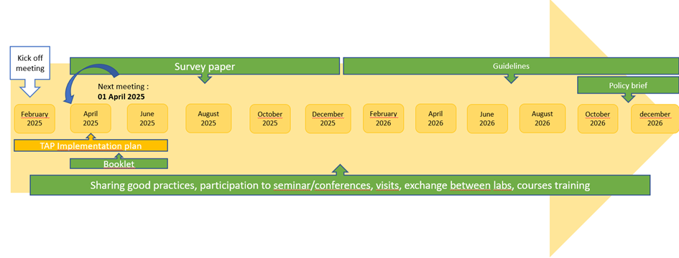

Additionally, a policy brief will be drafted by WP3 partners. The objective of this policy brief is to identify key strategies and recommendations aimed at enhancing the participation of widening countries in cultural heritage projects. The brief will focus on addressing the specific challenges faced by these countries in accessing and engaging with European cultural heritage initiatives. By emphasizing the importance of targeted capacity-building efforts, improved communication channels, and stronger connections with national ministries, the brief will propose actionable steps for increasing awareness and fostering participation in these projects. Additionally, it will highlight the role of the European Commission, emerging consortia, and National Contact Points (NCPs) in facilitating greater inclusivity, ensuring that widening countries can effectively contribute to and benefit from cultural heritage initiatives at the European level.

# **ANNEX I. List of attendees**

|  | NAME | INSITUTION | PRESENCE |
| --- | --- | --- | --- |
| 1 | Esther Diez Cebollero | ANR | IN PERSON |
| 2 | Matilde Monnier | ANR | IN PERSON |
| 3 | Julia Gavarrino | ANR | IN PERSON |
| 4 | Edith Santa Cruz | ANR | IN PERSON |
| 5 | Inès Alterio | ANR | IN PERSON (hour 1) |
| 6 | Amanda Loeffen | Project Aid / SD-WISHEES | IN PERSON |
| 7 | Domnica Cotet | UEFSCDI | IN PERSON |
| 8 | Cristina Balanceu | Museion project  BEIA | *ONLINE* |
| 9 | George Sciu | Museion project  BEIA | *ONLINE* |
| 10 | Rodica Ion | Scan4Art project  ICECHIM | IN PERSON |
| 11 | Lucia Usurelu | ProEntranse | IN PERSON |
| 12 | Nicu Vrabie | AROMANCE | IN PERSON |
| 13 | Alexander Borg | EWA  Chadwick trails and Cohesion Fund | IN PERSON |
| 14 | Nikos Skondras | Alteraqua project  GWP-Med | *ONLINE (DAY 1)* |
| 15 | Vasiliki Pougkakioti | LIFE-IP AdaptInGR project  ELLINIKI ETAIRIA | IN PERSON |
| 16 | Eleni Maistrou | LIFE-IP AdaptInGR project  NTUA | IN PERSON |
| 17 | Pierre Antoine Versini | PENATE project  Ecole Nationale des Ponts et Chaussées | IN PERSON |
| 18 | Valérie Grouet Brunet | AGAPE project  Université de Clermont Auvergne | IN PERSON |
| 19 | Aurélie Talon | DIBIM project  Institut de Géographie Nationale | IN PERSON |
| 20 | Oana Orza | Museion project  BEIA | *ONLINE* |
| 21 | Robert Streche | Museion project  BEIA | *ONLINE (DAY 1)* |
| 22 | Véronique Briquet-Laugier | European Commission Expert  Aqualegacy | IN PERSON (DAY 2) |
| 23 | Mary Kelly Quinn | School of Biology & Environmental Science, University College Dublin | *ONLINE (DAY1)* |
| 24 | Marnix Surgeon | European Commission | *ONLINE (DAY2)* |

# **ANNEX II. Agenda of the TAP kick-off meeting**

### **AGENDA – TAP Kick-Off**



**DAY 1: Thursday 20th February – 14h-17h30**

**86 rue Regnault, 75013 PARIS at Oxygène room (-1)**

| TIME | SESSION | SPEAKERS |
| --- | --- | --- |
| 14h-14h30 | **Introduction & Welcoming words**  **Icebreaker** | Inès Alterio – ANR  Deputy head of Department |
| 14h30-14h45 | **Aims of the Workshop & Agenda**   * Kick-off objectives * Expected outcomes: know each other, identify collaborations potential, elect a scientific coordinator, implementation plan * Tour de table: who is who | Matilde Monnier - ANR  SD-WISHEES WP3 |
| 14h45-15h | **What is the TAP?**     * What is the TAP: network of projects * Objectives, themes, strategic goals, expected outcomes * Governance: who does what? * Timeline of the TAP   **Q&A** | Esther Diez Cebollero - ANR  Water JPI Coordinator  SD-WISHEES WP3 Lead |
| 15h-15h15 | **Learning more about the TAP:**  **the example of Water JPI** | Professor Mary Kelly-Quinn - University College Dublin |
| 15h15-15h30 | **Q&A** |  |
| 15h30-16h | **Getting to know each other: presentation of the national projects (1)**   1. Museion (Romania) 2. Scan4Art (Romania) 3. Alteraqua (Malta) 4. Chadwick Trail (Malta) 5. Cohesion Fund (Malta) | Project coordinators |
| 16h00-16h30  Coffee Break | | |
| 16h30-17h | **Getting to know each other: presentation of the national projects (2)**     1. Project from CPIU IFAD programme (Moldova) 2. Life-IP AdaptinGR (Greece) 3. DIBIM (France) 4. AGAPE (France) 5. PENATE (France) | Project coordinators |
| 17h-17h30 | **Recap & Questions**    **Mentimeter** | ANR |
| 18h30  Social Dinner | | |

**DAY 2: Friday 21st of February – 9h-13h**

**86 rue Regnault, 75013 PARIS at Oxygène room (-1)**

| TIME | SESSION | SPEAKERS |
| --- | --- | --- |
| 9h-10h30 | **Group discussion 1:**  **First steps towards the Implementation Plan (1)**   1. Identifying common grounds between scope of projects 2. Activities / Productions to be delivered 3. Election of a Scientific coordinator 4. TAP Acronym 5. What support required? | TAP members |
| 9h-10h30 | **Group discussion 2:**  **Widening challenges**   1. Strategic alignment 2. Financial management of projects 3. Capacity building and institutional support 4. Encouraging participation & reducing barriers | Non-TAP members &    Funding agencies    Marnix Surgeon – European Commission |
| 10h30-11h00  Coffee Break | | |
| 10h30-12h | **Group discussion 1:**  **First steps towards the Implementation Plan (2)** | TAP members |
| 12h-12h30 | **Implementation Plan restitution** | Rapporteur  TAP members |
| 12h30-13h | **Next steps and closing thoughts** | ANR |
| 13h-14h  Lunch Break | | |